Online Retail Supply Chain Analysis Report
Dataset: link
1. Introduction
This project analyses an online retail dataset to support supply chain and inventory management decisions. Using Python (Google Colab) for data cleaning and exploratory data analysis (EDA) and Power BI for interactive dashboards, the goal was to generate actionable insights for demand forecasting, stock replenishment, and operational efficiency.
2. Dataset Overview
The dataset contains transactional sales data for a UK-based online retailer:
- Invoice Number
- Product Description
- Quantity & Unit Price
- Invoice Date
- Customer ID
- Country
Data Cleaning Steps:
- Removed records with missing product descriptions and customer IDs.
- Filtered out negative or zero quantities and prices.
- Converted invoice date to datetime format.
- Created derived metrics: Total Revenue, Units Sold, Month, Year.
Metric | Value
Total Revenue | £8.91M
Total Orders | 17,000
Total Customers | 4,338
Average Order Value | £515.65
Key Metrics:

Highlights:
- Revenue shows seasonal peaks in November (£1.16M) and dips in February (£0.45M).
- Top 3 products contribute 46% of revenue.
- UK dominates sales (~82% of revenue), with limited international performance.
3. Inventory and Demand Analysis
3.1 Monthly Demand Trends
- Peak sales observed in November (£1.16M) and lowest in February (£0.45M), indicating seasonal demand fluctuations.
- Consistent growth between July–November suggests periods of high product turnover requiring proactive stock planning.

Supply Chain Implication: Stock levels should be aligned with seasonal demand, ensuring high-demand products are available during peak periods and minimizing overstock during low seasons.

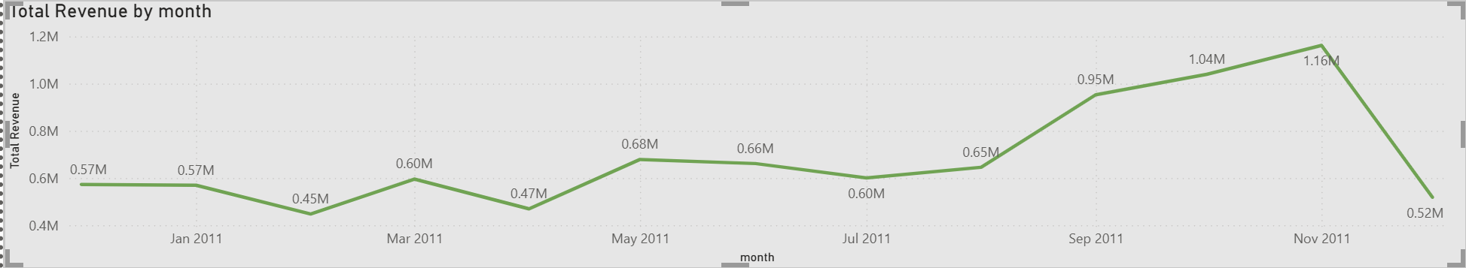Fig 1: Line chart of total revenue per month with peaks highlighted.
3.2 Product-Level Insights

Rank | Product Description | Revenue (£K)
1 | PAPER CRAFT, LITTLE BIRDIE | 168
2 | REGENCY CAKESTAND 3 TIER | 143
3 | WHITE HANGING HEART T-LIGHT HOLDER | 100
4 | JUMBO BAG RED RETROSPOT | 85
5 | MEDIUM CERAMIC TOP STORAGE JAR | 81
6 | POSTAGE | 78
7 | PARTY BUNTING | 69
8 | ASSORTED COLOUR BIRD ORNAMENT | 57
Insights:
- Top 3 products account for 46% of total revenue → require careful inventory planning and priority replenishment.
- Lower-performing products can be bundled or discounted to optimize stock turnover.
- Non-product revenue items (e.g., postage) should be separated from inventory metrics to ensure accurate stock analysis.
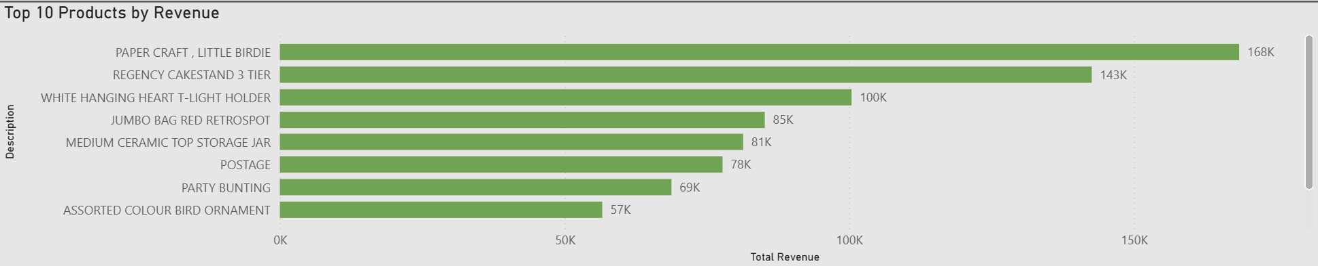Fig 2: Horizontal bar chart of top 10 products by revenue.

3.3. Customer and Order Insights
- Total Customers: 4,338
- Average Orders per Customer: ~4/year
Implications:
- Average of ~4 orders per customer annually.
- High repeat purchase rates indicate stable demand patterns, useful for forecasting reorder quantities and warehouse allocation.

3.4. Geographic Demand Distribution

Country | Revenue (£M)
United Kingdom | 7.3
Netherlands | 0.3
EIRE | 0.3
Germany | 0.2
France | 0.2
Australia | 0.1
Spain | 0.1
Switzerland | 0.1
Belgium | 0.0
Sweden | 0.0
Insights:
- UK dominates (~82% of revenue) → focus inventory on domestic distribution.
- International markets show potential growth → consider regional stock allocation and logistics optimization..
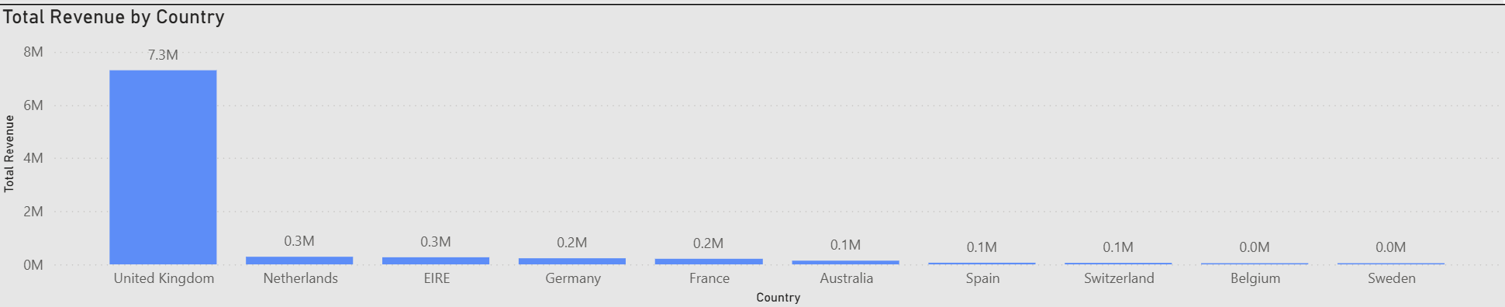Fig 3: Column chart of revenue by country with UK highlighted.
4. Supply Chain Recommendations
- Inventory Optimization:
  - Align stock levels with seasonal demand peaks.
  - Prioritize replenishment for top-selling products.
- Forecasting & Planning:
  - Use dashboards to track monthly demand, units sold, and reorder points.
  - Predict low-demand periods and adjust warehouse capacity accordingly.
- Product Portfolio Strategy:
  - Bundle slower-moving products with high-demand items to reduce excess stock.
  - Review non-product items to avoid skewed inventory reports.
- International Logistics:
  - Strategically allocate inventory to growing markets (Netherlands, EIRE) to reduce shipping time and cost.
- Operational Monitoring:
  - Implement Power BI dashboards for continuous tracking of inventory, stock-outs, demand patterns, and KPIs to support data-driven supply chain decisions.
5. Conclusion
The analysis provides critical insights for supply chain management, including demand forecasting, inventory optimization, and stock allocation. By leveraging data-driven dashboards and analytics, the retailer can improve operational efficiency, minimize stockouts or overstocking, and support strategic inventory planning to drive sustainable growth.

